**World Social Forum-Feb 18, 2024**

**Revitalizing Rural Reconstruction Movements: Addressing Multiple Crises**

**Background:**

The **Rural Reconstruction Movement** was started in China in the 1920s by **James Yen, Liang Shuming** and others to revive the Chinese villages in the face of the onslaught of modernization and industrialization. Similar movements have burgeoned in many countries in Asia (and globally), such as the PRRM in the Philippines (set up in 1952), or the RRN in Nepal (started in 1989). Many movements for rural regeneration, though not necessarily named as RRM, have played a prominent role in rural community building, such as the AIPSN in India. As the World Social Forum 2024 (#WSF24) is going to be held in Kathmandu, Nepal during 15-19 February 2024, an event is scheduled for February 18, 2024. This event aims to revisit the significance of the Rural Reconstruction Movement in the context of contemporary global challenges. As the world faces multiple crises encompassing climate change, economic disparities, and social inequalities, the principles and strategies of rural reconstruction remain profoundly relevant.

**Key Focus Areas**:

* **Historical Significance**: Evolution and foundational principles of the Rural Reconstruction Movements, emphasizing their pivotal role in addressing rural poverty and strengthening community development.
* **Relevance in Current Crises**: relevance of rural reconstruction strategies, integrated rural development approaches, community participation and education, sustainable practices, and social justice principles.
* **Community Empowerment and Sustainability**: Highlighting the importance of community-driven initiatives, success stories and lessons learned from grassroots movements focusing on small peasant agriculture, food sovereignty, and equitable access to resources, education, healthcare, and socio-economic empowerment.
* **Pathways Forward**: discussions on leveraging the ethos of rural reconstruction to shape effective strategies for building resilient communities, combating inequality, and fostering sustainable development, particularly in the context of the current global challenges.

**Objective:**

To facilitate knowledge exchange, collaborative dialogues, the formulation of actionable recommendations, and the consolidation of a network of Asian rural reconstruction movements.

**Expected participants**: 500

**Venue**: World Social Forum 2024, Kathmandu, Nepal

**Proposed Date:**  18 Feb, 2024 (two sessions in the afternoon, 2.00-5.30pm)

**Organizers:**  RRN, PRRM, IIRR, Global University of Sustainability

**Co-organizers:**  ARENA, SAAPE, LDC Watch??

**PROPOSED BANNER [DRAFT]**

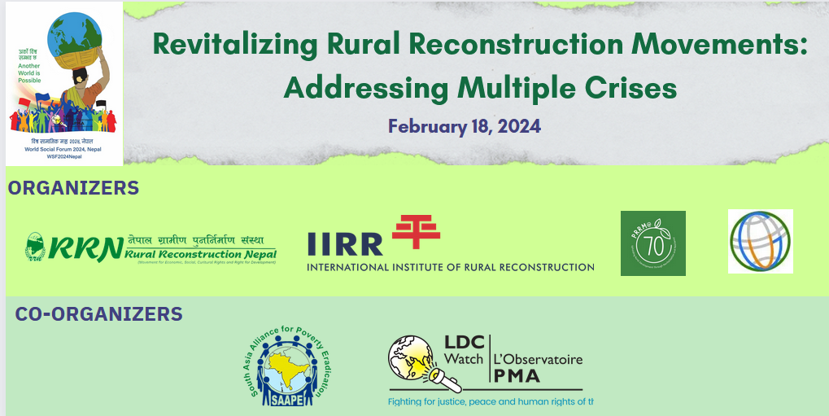

Speakers invited from China, Nepal, Philippines, India, and possibly Thailand/Bangladesh/Cambodia….

It is recommended that each country’s speaker(s), within a given period of time for each country’s presentation (for example 20 minutes), will give a brief account of the history of the rural reconstruction movement (RRM) from its start, then focus on recent developments and challenges, and showcase some community success stories and/or best practices in countering climate change impacts, reducing poverty and inequality, and other issues such as water, food, or seeds.

After the country presentations, there will be a dialogic exchange on commonalities and differences in approaches, future collaborative projects, and actionable recommendations.

**Confirmed Speakers:**

China: WEN Tiejun, YAN Xiaohui

Nepal: Arjun KARKI, ….

Philippines: Cathy Thiongson

India: Anita Rampal

Thailand: ?

Bangladesh: ?

Cambodia ?